AFRICAN SOLIDARITY CIVIC ORGANISATION NPC (ASCO)
Privacy and POPIA Notice
BOARD-APPROVED FINAL DOCUMENTATION
FINAL DOCUMENTATION — BOARD APPROVED; EXECUTION / FILING DETAILS TO BE RECORDED
This document records the Board-approved ASCO governance model and policy position. Legal effectiveness, execution, statutory-register updates and filing or registration requirements must be completed by the authorised persons and recorded in the approval register. The Memorandum of Incorporation remains subject to the Companies Act 71 of 2008 and applicable filing requirements.
DOCUMENT CONTROL
Version: 1.0 | Prepared and Board-approved: 10 September 2026 | Resolution reference: To be entered in the approval register | Effective date: To be recorded where applicable | Next review: To be recorded
1. NOTICE STATUS
This draft must be completed with the designated Information Officer and approved contact before publication.
2. RESPONSIBLE PARTY
Responsible party: African Solidarity Civic Organisation NPC. Address and contact: 49 Rif Road, Manor Gardens, Durban, KwaZulu-Natal, 4001, South Africa; info@africansolidaritycivic.org. Information Officer: TO BE DESIGNATED AND REGISTERED.
3. DATA COLLECTED
ASCO may collect identity, contact, membership, volunteer, donation, safeguarding, communication and programme-participation information only where necessary and with appropriate notice.
4. PURPOSES
Purposes include membership administration, volunteering, donations, communications, safeguarding, programme delivery, records, compliance and reporting.
5. RIGHTS AND RETENTION
Data subjects may request access or correction and may raise privacy concerns. Retention periods must be documented by category. Data must be secured and shared only with authorised staff, processors, partners or authorities where justified.
6. CHILDREN AND MARKETING
Applicants under 18 require parent/guardian consent where applicable. Marketing consent must be separate and optional. Donations are optional and do not determine membership.
7. THIRD PARTIES
Hosting, payment, email, social-media, messaging and exchange-rate providers must be identified in the final notice, including international-transfer information where applicable.
8. COMPLAINTS
Information Regulator contact and internal escalation details must be inserted before publication.

Place of approval / execution: 49 Rif Road, Manor Gardens, Durban, KwaZulu-Natal, 4001, South Africa
BOARD APPROVAL SIGNATURES
The following signatures are copied from the signed ASCO documents supplied for this purpose. They record Board approval/acknowledgement in the stated capacities; statutory effectiveness, filing and authority remain subject to the applicable approval and filing process.
CHAIRPERSON / FOUNDER  Ms Busisiwe Makhosi Shandu    Date: 6 September 2026  Signature copied from supplied signed document | DIRECTOR: ICT AND COMMUNICATIONS  Mr Thapelo Nelson Maqalika  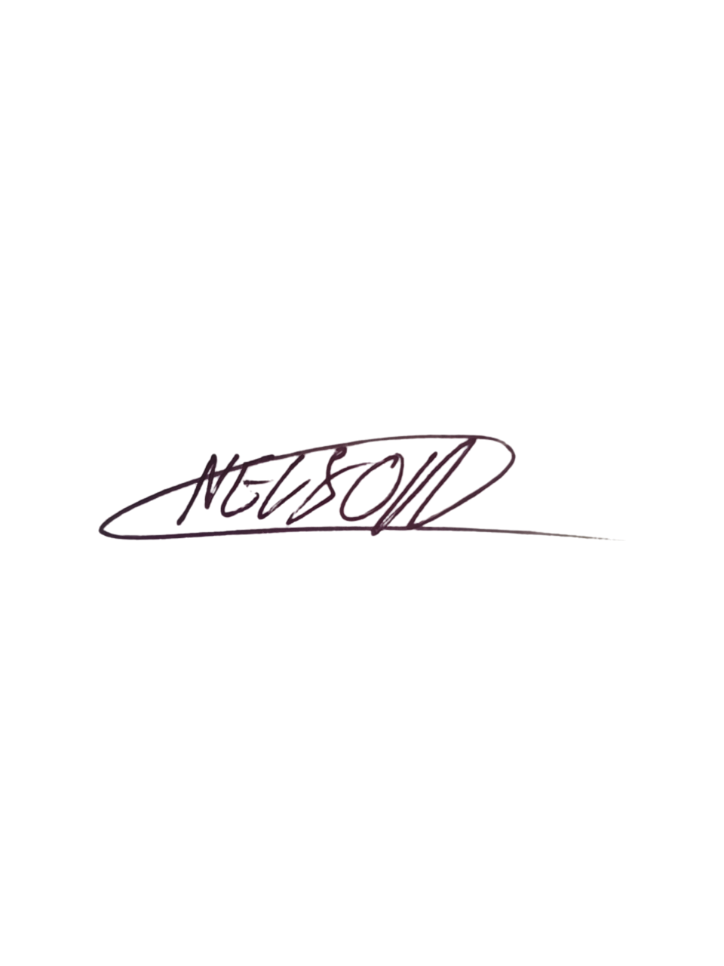  Date: 6 September 2026  Signature copied from supplied signed document
EXECUTIVE DIRECTOR  Mr Bhekisisa Shandu  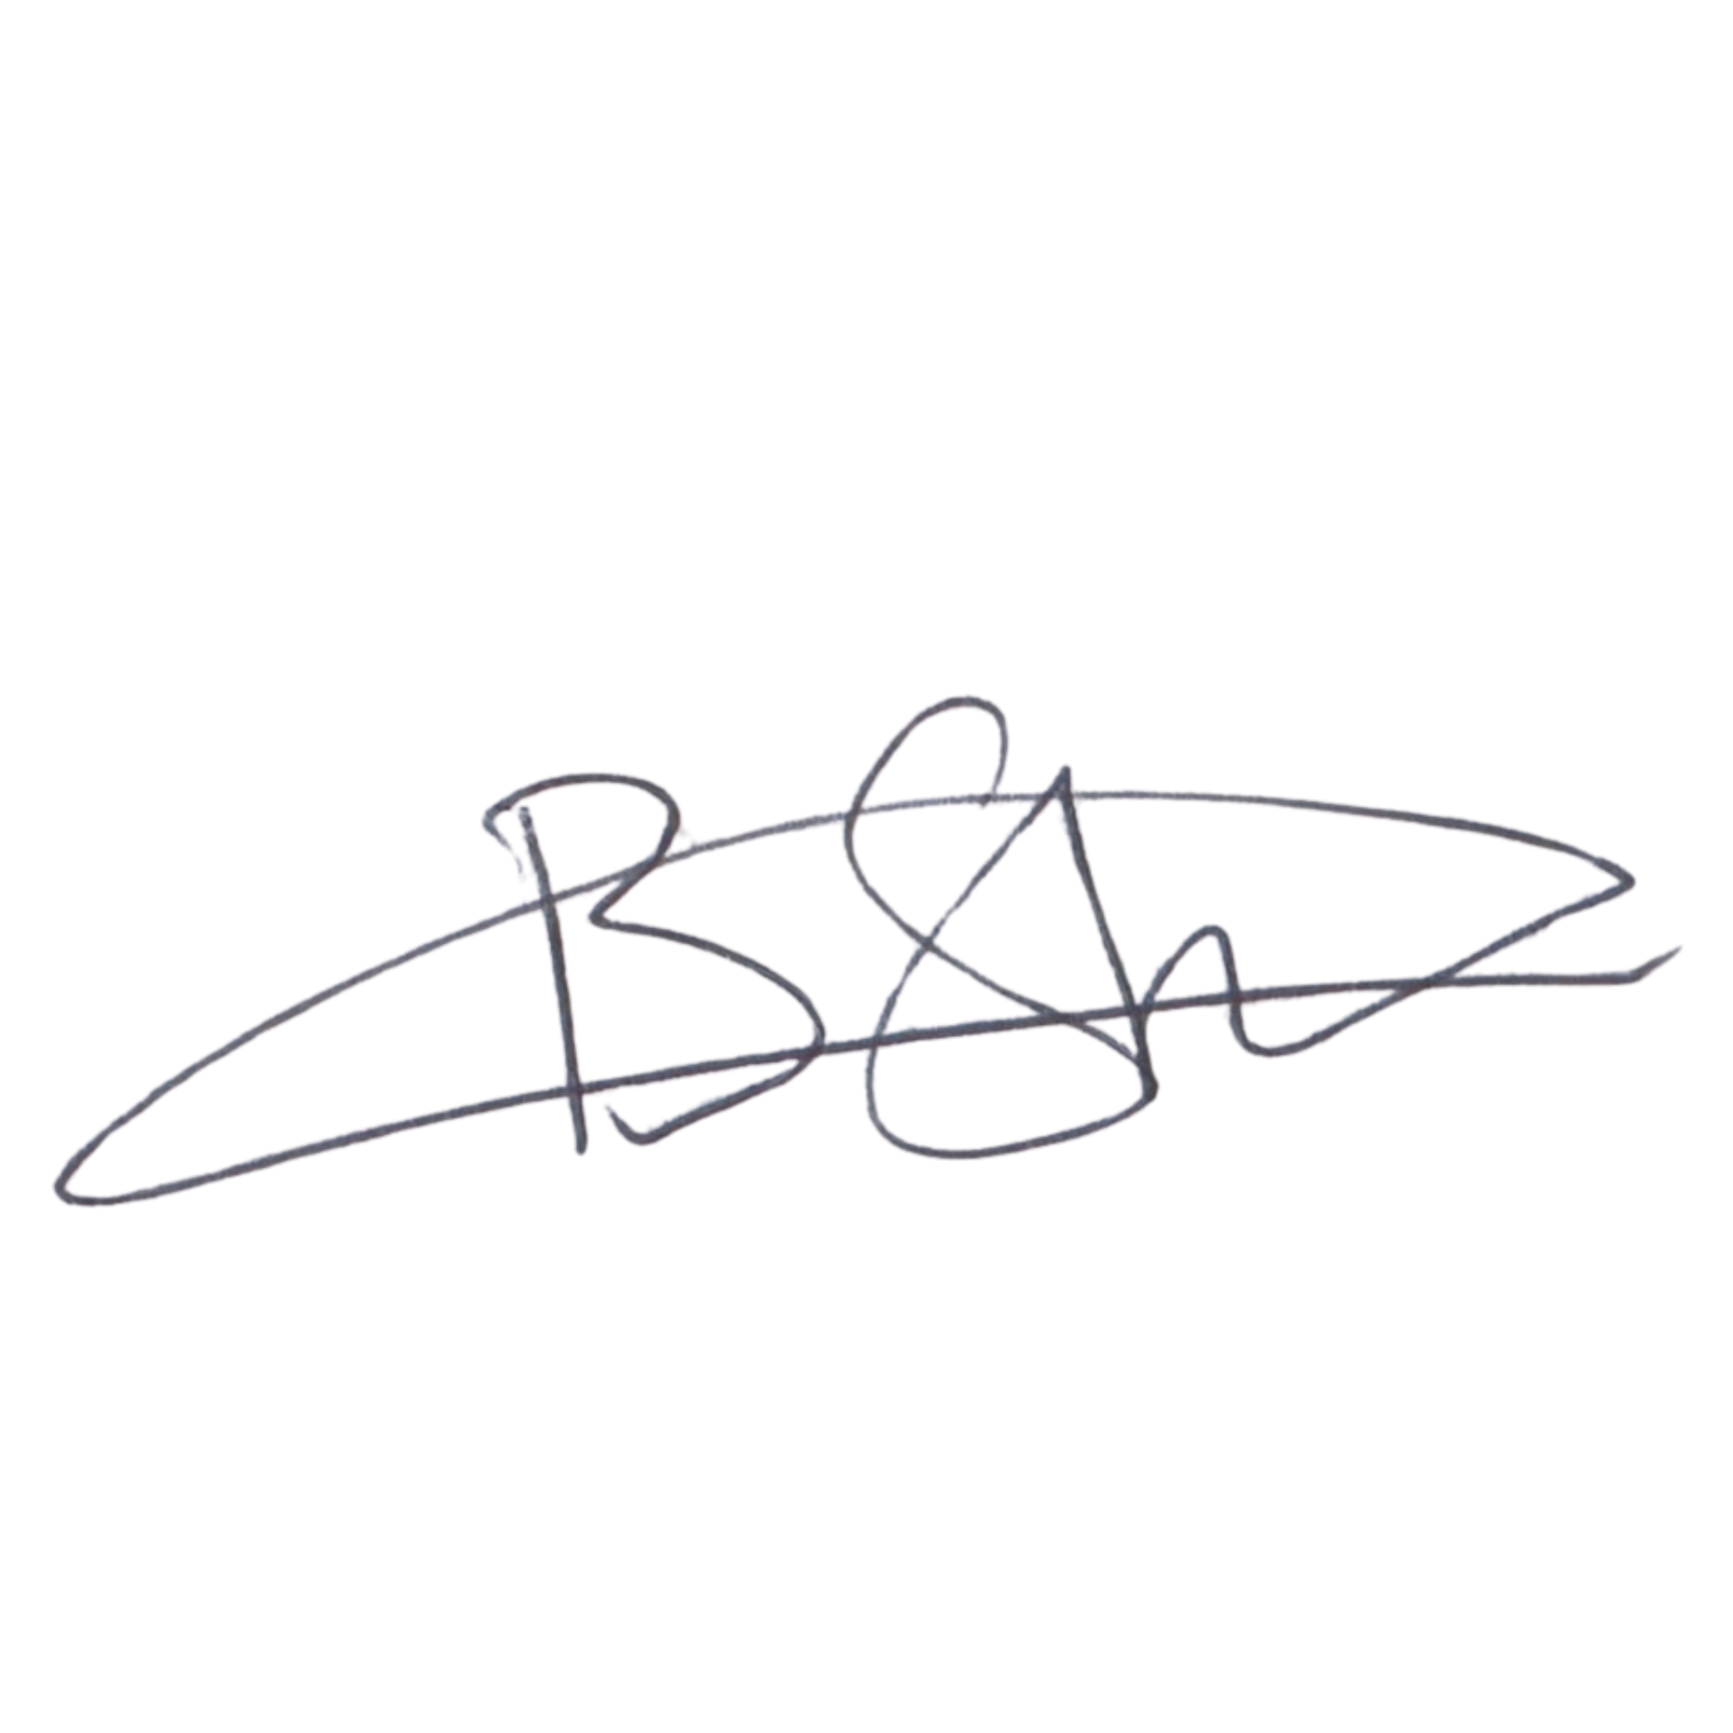  Date: 6 September 2026  Signature copied from supplied signed document | DIRECTOR: PEOPLE AND CULTURE / FINANCE AND PROCUREMENT  Mr Khulekani Gumede  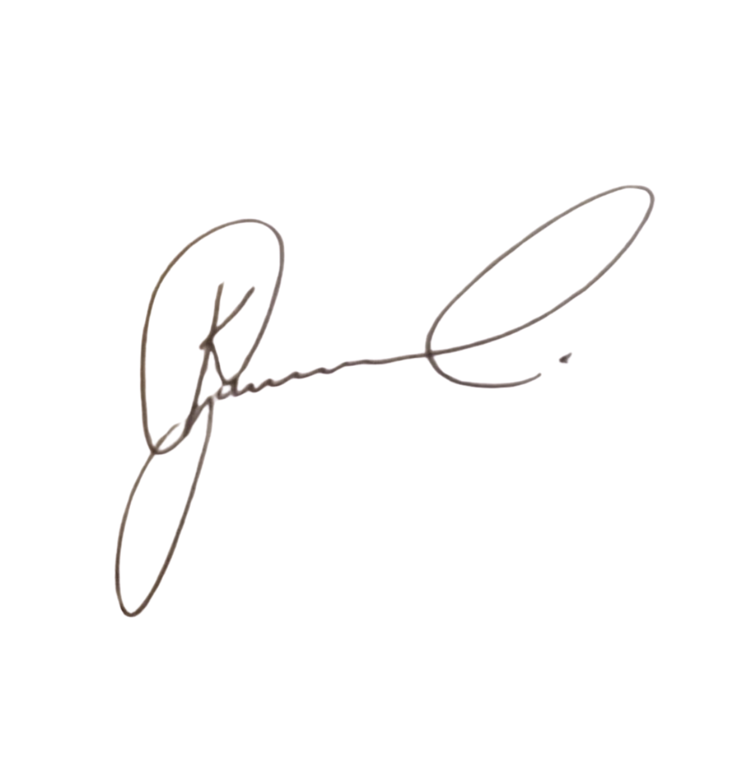  Date: 6 September 2026  Signature copied from supplied signed document

